Query-Object

Overview:
The query-object (IQuery) provides the interfaces used to represent a user-defined query. The query consists of outputs (represented by IOutputTreeNode) and constraints (represented by IConstraints). User defined conditions (e.g. Participant.sex = ‘female’) are represented by ICondition. Conditions on different attributes of an entity are grouped together as a rule (represented by IRule). Various rules/expressions on an entity can be logically grouped into an expression (represented by IExpression). An expression thus consists of operands (i.e. rules or sub expressions; this is represented by IExpressionOperand) connected by logical operators (AND, OR). Operands in an expression can also be parenthesized.
The various expressions thus formed need to be linked together. Two expressions are linked by an association (represented by IAssociation). These linkages among the expressions constitute the join graph (represented by IJoinGraph).

Class diagram:
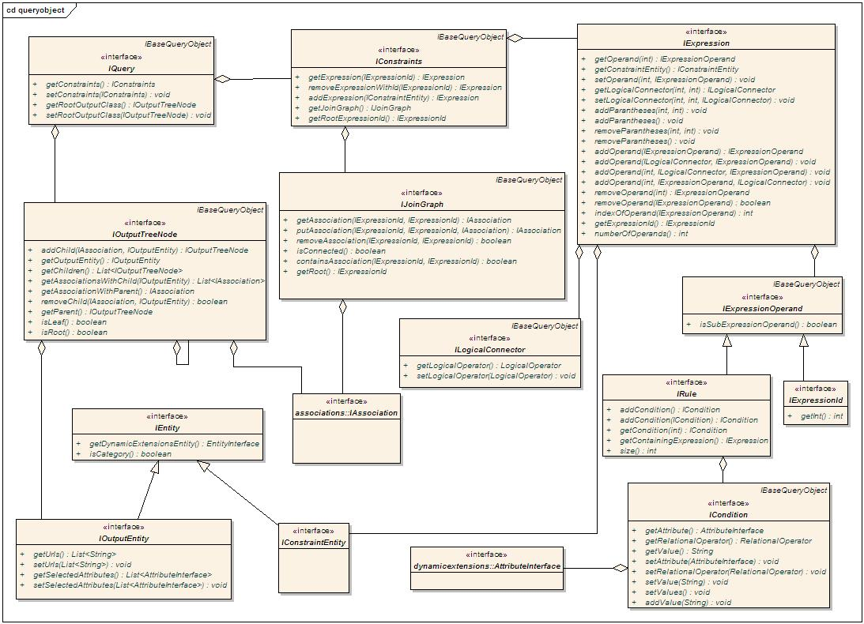
Interfaces that compose the query-object

Interface Summary
ICondition | A condition containing an attribute, relational operator and value(s). E.g. participant.sex = 'Male'
IConstraintEntity | An entity that is associated with a constraint
IConstraints | Contains information about the constraints of a query. It contains a list of IExpressions that is indexed by IExpressionId. This is global storage location for all expressions in a query. Only calling the addExpression method here can create an IExpression. It also contains a join graph for specifying how the expressions are linked together.
IExpression | A list of operands, and the logical connectors (AND, OR) together form a logical expression. The connectors are identified by the position of the operands on either side. An IExpression belongs to a constraint entity and constraints on another associated entity will be present as a sub expression on the associated entity. Conversely, if an expression has a sub expression, there must an association in the join graph from the parent expression to the sub expression.  Note: "sub expression" refers to an operand that is the IExpressionId of the child expression. The entity of the sub expression will generally be different from the entity of this expression (exception is when a class is associated to itself, e.g. Specimen). The expression for an ExpressionId is found from IConstraints.
IExpressionId | An immutable wrapper around int used to uniquely identify an expression within a query. It is auto generated when an expression is added to a query.
IExpressionOperand | A marker interface for an operand. An operand is either a sub expression (in which case, the corresponding expression id is added), or a rule.
IJoinGraph | A rooted, directed acyclic graph with expressions as vertices, and associations as edges. The graph will always contain all the expressions' ids (obtained from IConstraints) as vertices. The vertices will be added to/removed from the Joingraph as and when expressions are added to/removed from IConstraints. The methods in Joingraph can only add/remove associations among the vertices.  If v1 and v2 are two vertices, the direction will be v1->v2 if v2 is a sub expression of v1. The user of the API will generally build the joingraph based on metadata, and in cases of ambiguity, the user will help forming this graph. This graph basically determines the join conditions in the query. E.g. for each edge (v1, v2) between two vertices v1 and v2, there will be a join between the functional classes of the expressions denoted by v1 and v2; and the join condition is determined by the info in the IAssociation.
ILogicalConnector | Represents a logical connector (AND / OR). The nesting represents the number of parentheses (depth of parentheses) around the logic portion (AND or OR) of the connector.
IOutputEntity | An entity associated with the output tree node.
IOutputTreeNode | A tree node to represent an output entity that is a part of the outputs of the query. It is a tree with vertex as IOutputEntity and edge as IAssociation.
IQuery | The query object. This is the unit built from UI, persisted, and from which queries will be built.
IRule | A list of conditions, on different attributes of an Entity.  Note: The conditions in a rule are implicitly linked by AND condition.

